**IBM Cloud Service**

**Team Leader: A.G Abishega**

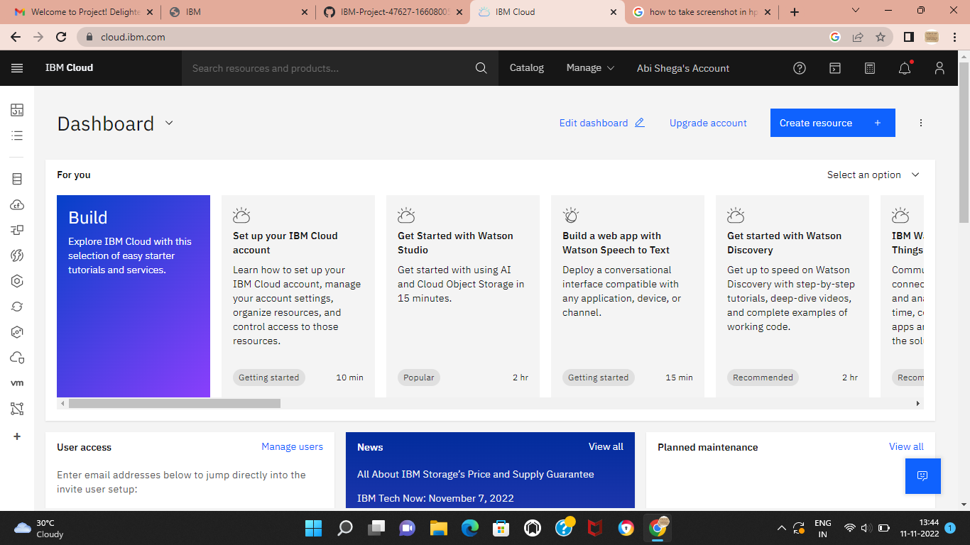

**Team Member 1: A.S Anusree**

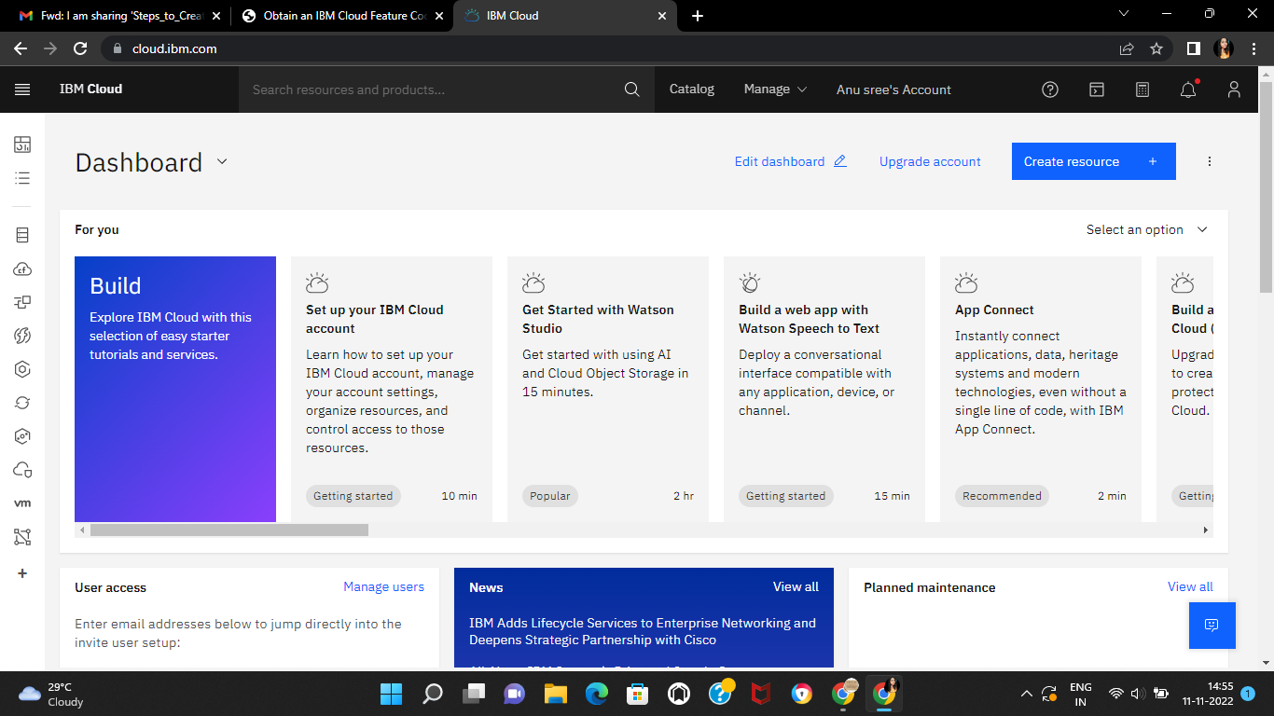

**Team Member 2: A Christeena Joy**

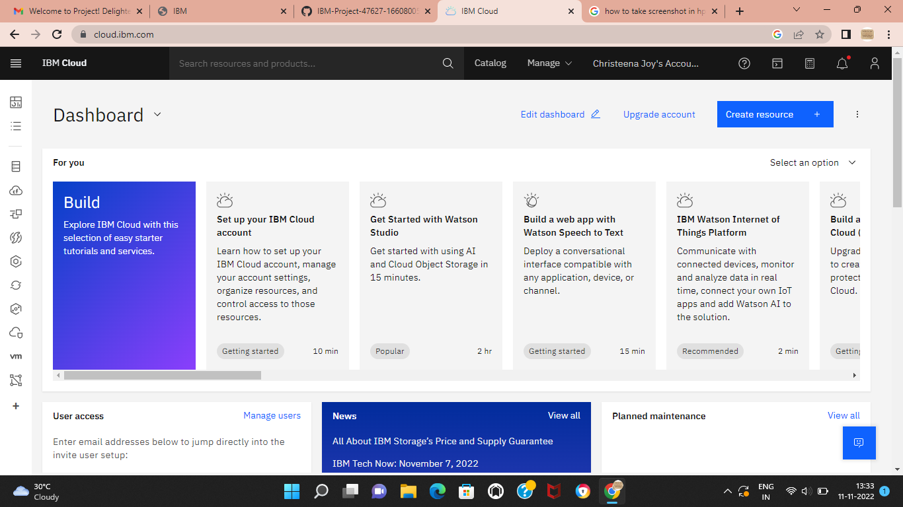

**Team Member 2: J God Shaly**

